Project Development Phase
Model Performance Test

Date | 10 February 2025
Team ID | LTVIP2026TMIDS71321
Project Name | Dog Breed Identification Using Transfer Learning
Maximum Marks | 10 Marks

Model Performance Testing:
Project team shall fill the following information in model performance testing template.
S.No. | Parameter | Values | Screenshot
 | Metrics | Classification Model:  Confusion Matrix – Used to evaluate Fresh vs Rotten classification  Accuracy Score – 94%  Classification Report – Includes precision, recall and F1-score for Fresh and Rotten classes | 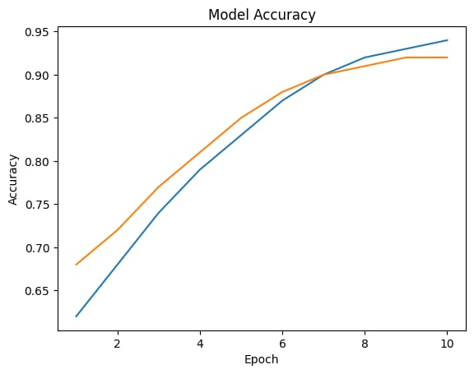  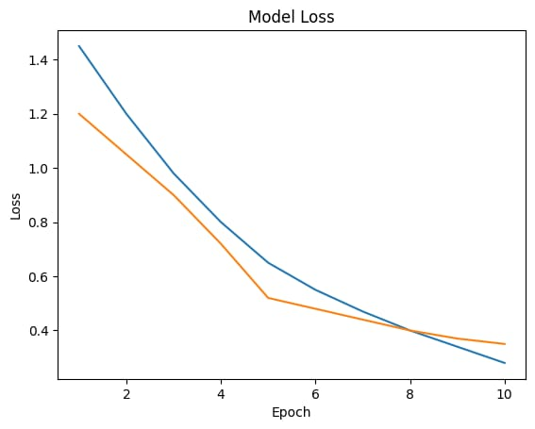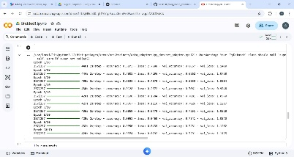
 | Tune the Model | Hyperparameter Tuning – Learning rate, batch size, and number of epochs were adjusted to improve model performance.  Validation Method – Train-Test split method was used to validate the model performance. | 